Code Metrics

Below screen shot the code metrics.

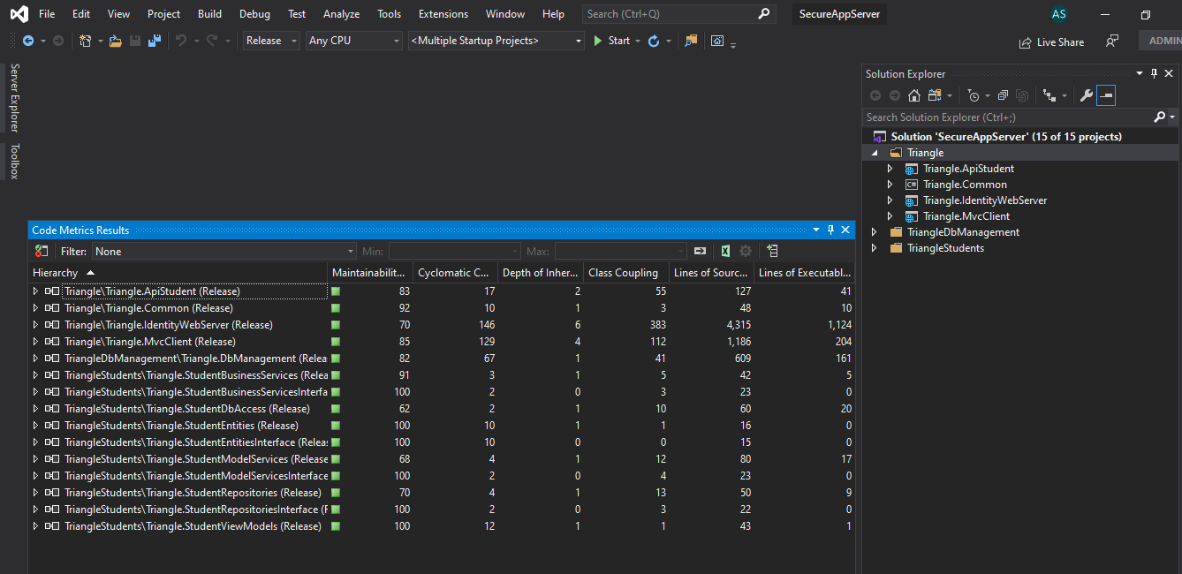

1. Triangle Folder

Following core application

* 1. Triangle.ApiStudent [Backend API]
  2. Triangle.IdentityWebServer [Identity API]
  3. Triangle.MvcClient [UI-API]

1. TriangleDbManagement Folder
   1. Triangle.DbManagement

It is used by All Domain to connect and access from database

1. TriangleStudents Folder is a Domain Specific
   1. Triangle.StudentViewModels
   2. Triangle.StudentBusinessServices
   3. Triangle.StudentBusinessServicesInterface
   4. Triangle.StudentModelServices
   5. Triangle.StudentModelServicesInterface
   6. Triangle.StudentRepositories
   7. Triangle.StudentRepositoriesInterface
   8. Triangle.StudentEntities
   9. Triangle.StudentEntitiesInterface
   10. Triangle.StudentDbAccess

Client ⬄ Identity ⬄ ApiStudent

* UI Bootstrap not implement Overall
* Student DB not created
* //Note Ideally URI come from appsetting.json or database but for speeding the task; hardcoded it